

July 5, 2005

FOR IMMEDIATE RELEASE

Contact:
Nicole Leaper
The Bullseye Connection Gallery
300 NW 13th Avenue
Portland, OR 97209
T: 503-227-0222
F: 503-227-0008
nicoleleaper@bullseyeglass.com

From painterly to sculptural, Bullseye Connection Gallery artists present a diverse portrait of contemporary glass art at GlassWeekend 2005.

Wheaton Village, Millville NJ – The Bullseye Connection Gallery is pleased to exhibit at GlassWeekend, a biennial international symposium and exhibition of contemporary glass at Wheaton Village in Millville, NJ, July 15 - 17, 2005.

Bullseye will feature contemporary works in international studio glass by the following artists:

Catherine Aldrete-Morris (Australia)
Giles Bettison (Australia)
Steve Klein (USA)
Alicia Lomné (USA)
Catharine Newell (USA)
Richard Whiteley (Australia)

Bullseye’s artists showcase the diversity of the glass medium, ranging from Newell’s painterly wall works to the graphic, sculptural work of Klein and Lomné. Bettison’s murrine forms housed in transparent blocks contrast with the more architectural work of Whiteley and Aldrete-Morris. Viewed together, the works offer a glimpse of a contemporary medium encompassing a wide array of techniques and subtle expressions.

Since 1985, GlassWeekend has brought together the world’s leading glass artists, collectors, galleries, and museum curators for a three-day weekend of exhibitions, lectures, hands-on glassmaking, artists, demonstrations and social events.

GlassWeekend events are held at Wheaton Village, home of the Creative Glass Center of America and the Museum of American Glass. Further GlassWeekend information can be found at www.wheatonvillage.org.

Attend the exhibition: GlassWeekend 2005

Where: Wheaton Village
Millville, NJ

When: July 15 - 17, 2005

To view exhibitions, find out more about The Bullseye Connection Gallery and download artist statements and curricula vitae, please visit the gallery online at bullseyeconnectiongallery.com.

To request additional information, images, or schedule a studio tour or interview with an artist or gallery staff member, please contact Nicole Leaper by phone at 503-227-0222 or by email at nicoleleaper@bullseyeglass.com

###
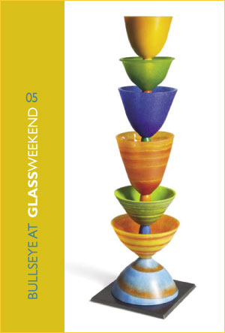
Alicia Lomné
Stacking #10
2005
glass, pâte de verre
26.75 x 7.875 x 7.875 inches

