

300 NW 13th Avenue
Portland, OR 97209 USA
503-227-0222 phone
503-227-0008 fax
gallery@bullseyeglass.com
www.bullseyegallery.com

October 8, 2009 FOR IMMEDIATE RELEASE

Giles Bettison: Solace
Detailed patterns in kilnformed glass recall lace and woven tapestry.

When: November 3 – December 29, 2009
Tuesday – Saturday, 10:00 am – 5:00 pm
(and by appointment)

Where: Bullseye Gallery
300 NW 13th Avenue
Portland, OR 97209 USA
View map

Artist Reception: Wednesday, November 4, 5:30 – 7:30 pm

First Thursday: November 5, open until 8:00 pm
December 3, open until 8:00 pm

Portland, OR - Bullseye Gallery is pleased to announce its third solo exhibition of work by Giles Bettison on view from November 3 – December 29, 2009. Solace presents a selection of kilnformed glass wall panels and vessel forms inspired by the grand arches of Venetian architecture and the delicate patterns of lace textiles.

"Movement through life is manifest in the things we do and patterns we live by,” says Bettison. “My work is an exploration of my movement through life, expressed in colours, patterns, and forms.”

Bettison, a graduate of Australia’s Canberra School of Art, is known for both artistic and technical innovation. While still a student, he applied an ancient Venetian glassworking technique – the fusing of bundled glass cane cut into patterned slices called murrine – to a new material: an American-made colored sheet glass. By using strips of sheet glass instead of cane, Bettison was able to achieve the appearance of woven textiles. He has applied this technique to a variety of forms, from traditional vessels to sculptural blocks mounted on steel.

Bettison has received a number of prestigious awards, including the Best New Talent award from UrbanGlass in New York (1999) and the Bavarian State Prize Gold Medal in Germany (2001). His work can be found in the permanent collections of the Museum of Arts and Design in New York, the Powerhouse Museum in Sydney, and the Museum of Applied Contemporary Art and Design in Lausanne, Switzerland.

To view artwork online or download artist statements and CVs, please visit www.bullseyegallery.com. To request high-resolution images or to schedule an interview, please contact Ryan Watson: ryanwatson@bullseyeglass.com or 503-227-0222.

About the gallery: Bullseye Gallery works with a select group of international artists with the aim of furthering exceptional design in glass through innovation in material and method. The gallery is part of Bullseye Glass Company, a maker of colored glass for art and architecture since 1974.
###
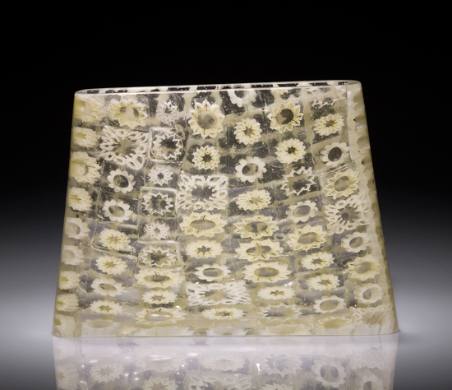
Giles Bettison, Lace 09 #30, 2009
blown and coldworked murrine glass, 7.25 x 10 x 2.75 inches
Photo: Andrew Dunbar
Image Courtesy of Bullseye Gallery

